**Scenario 1**

CODE

create or replace PROCEDURE process_monthly_interest

IS

BEGIN

UPDATE ACCOUNTS

SET BALANCE = BALANCE * 1.01

WHERE ACCOUNTTYPE = 'SAVINGS';

END;

exec process_monthly_interest;

OUTPUT

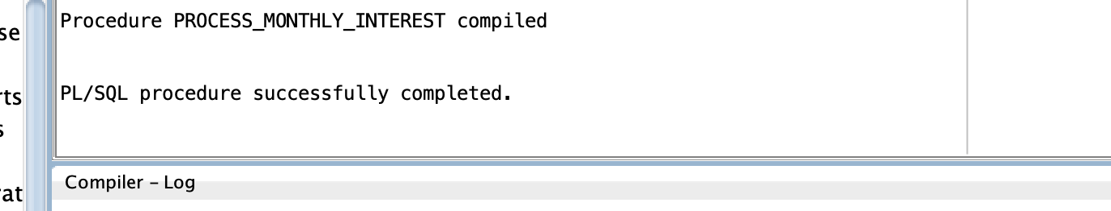

**Scenario 2**

CODE

CREATE OR REPLACE PROCEDURE UpdateEmployeeBonus (

p_deptno IN EMP.DEPTNO%TYPE,

p_bonus_percent IN NUMBER

)

AS

BEGIN

UPDATE EMP

SET SAL = SAL + (SAL * p_bonus_percent / 100)

WHERE DEPTNO = p_deptno;

—COMMIT; -- Optional: remove if you want to control transactions from the caller

EXCEPTION

WHEN OTHERS THEN

ROLLBACK;

DBMS_OUTPUT.PUT_LINE('Error: ' || SQLERRM);

END;

/

exec UpdateEmployeeBonus(5);

OUTPUT

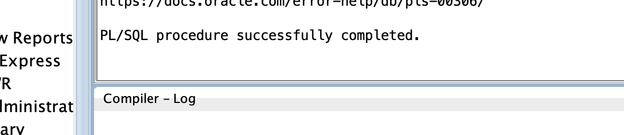

**Scenario 3**

CODE

create or replace PROCEDURE transferfunds (

from_account INTEGER,

to_account INTEGER,

amount NUMBER )

IS

fromacc_balance customers.balance%TYPE;

fromacc_cid customers.customerid%TYPE;

toacc_cid customers.customerid%TYPE;

BEGIN

SELECT c1.customerid, c1.balance, c2.customerid

INTO fromacc_cid, fromacc_balance, toacc_cid

FROM accounts a1

JOIN customers c1 ON a1.customerid = c1.customerid

JOIN accounts a2 ON a2.accountid = to_account

JOIN customers c2 ON a2.customerid = c2.customerid

WHERE a1.accountid = from_account

FOR UPDATE;

IF fromacc_balance >= amount

THEN

UPDATE customers

SET balance = CASE

WHEN customerid = from_account THEN balance - amount

WHEN customerid = to_account THEN balance + amount

END

WHERE customerid IN (from_account,to_account);

ELSE

RAISE_APPLICATION_ERROR(-20001,'BALANCE IS TOO LOW!');

END IF;

END;

exec transferfunds;

OUTPUT

